Day – 5 Assignment
- List all the main components you find inside a desktop PC after opening the cabinet, and write a short description (1-2 lines) for each.
Ans:
Component | Short Description
Motherboard | The main circuit board that connects and allows communication between all computer components.
CPU (Processor) | The "brain" of the computer that performs calculations and executes instructions.
CPU Cooler (Fan + Heatsink) | Keeps the CPU cool by removing excess heat generated during operation.
RAM (Memory) | Temporary storage that holds data and programs currently being used by the CPU.
GPU (Graphics Card) | Processes graphics, videos, and games. Example: NVIDIA GeForce GTX 1650.
SSD (Solid State Drive) | Fast storage device used to store the operating system, applications, and files.
HDD (Hard Disk Drive) | Traditional storage device that provides large storage capacity at a lower cost.
SMPS / Power Supply Unit (PSU) | Converts AC power from the wall outlet into DC power for computer components.
Cabinet Fans | Improve airflow inside the case and help maintain safe temperatures.
Heat Sink | Metal component that absorbs and dissipates heat from the CPU or GPU.
SATA Cables | Connect storage devices such as HDDs and SSDs to the motherboard.
Power Cables | Deliver electrical power from the PSU to the motherboard, storage devices, and GPU.
PCIe Expansion Slots | Slots on the motherboard used for graphics cards, Wi-Fi cards, and other expansion cards.
CMOS Battery | Maintains BIOS settings and system clock when the PC is powered off.
Optical Drive (Optional) | Reads and writes CDs, DVDs, or Blu-ray discs.

- Take clear photos or draw labeled diagrams of each step as you disassemble a desktop PC, and organize them in a document with captions explaining what you did at each step.<br><br><em><strong>Hint:</strong> Include steps like unplugging power, removing side panel, disconnecting cables, and removing RAM, HDD/SSD, and motherboard.</em>

Ans:
Desktop PC Disassembly Report
Objective
To safely disassemble a desktop PC and identify its internal components.

Step 1: Shut Down and Unplug the PC
Caption:
The computer was completely shut down and the power cable was removed from the wall socket to prevent electrical hazards.

Step 2: Remove the Side Panel
Caption:
The screws on the back of the cabinet were removed and the side panel was slid off to access the internal components.

Step 3: Identify Internal Components
Caption:
The motherboard, CPU cooler, RAM, GPU, SSD/HDD, and power supply were identified.
Diagram:

Step 4: Disconnect Power and Data Cables
Caption:
Power cables and SATA cables connected to storage devices and motherboard were carefully disconnected.

Step 5: Remove RAM Modules
Caption:
The retaining clips on both sides of the RAM slots were pressed outward, and the RAM modules were removed.

Step 6: Remove HDD / SSD
Caption:
The SATA and power cables were disconnected, and the storage drive was unscrewed and removed.

Step 7: Remove Graphics Card (GPU)
Caption:
The PCIe power connector was disconnected, the retaining screw removed, and the graphics card was carefully pulled out.

Step 8: Remove Motherboard
Caption:
After disconnecting all cables and removing mounting screws, the motherboard was carefully lifted out of the cabinet.

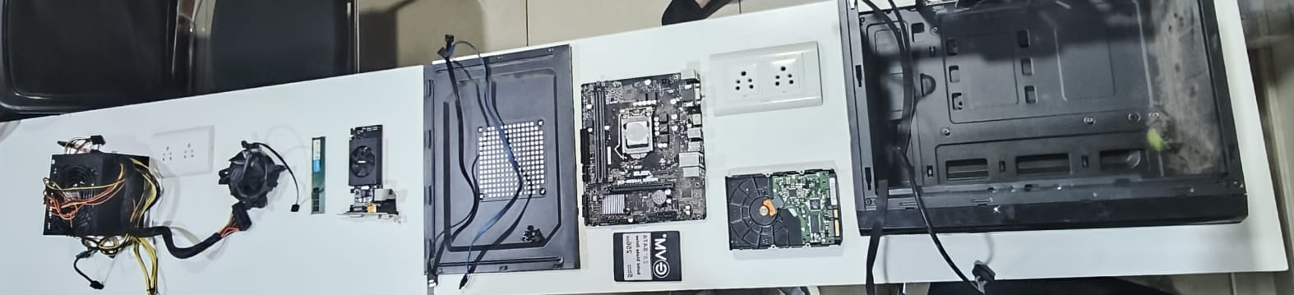

- Reassemble the PC you disassembled, documenting each step with a brief explanation of what you connected or installed and why the order matters.
Ans:
Desktop PC Reassembly Report
Objective
To reassemble the desktop PC after disassembly and ensure all components are correctly connected and functioning.

Step 1: Install the Motherboard
Caption:
The motherboard was carefully placed inside the cabinet and aligned with the mounting holes. Screws were tightened to secure it.
Why First?
The motherboard is the main component that holds and connects all other hardware.

Step 2: Connect the Power Supply (PSU)
Caption:
The SMPS/PSU was secured in its compartment and the main power cables were routed.
Why Second?
The PSU provides power to all components, and routing cables early improves cable management.

Step 3: Install the CPU and CPU Cooler
Caption:
The CPU was placed in the CPU socket and locked. Thermal paste was applied and the CPU cooler was attached.
Why Third?
The CPU must be installed before connecting RAM and other components around it.

Step 4: Install RAM Modules
Caption:
The RAM sticks were inserted into the DIMM slots until the retaining clips locked into place.
Why Fourth?
RAM installation is easier before large components such as the GPU are installed.

Step 5: Install HDD / SSD
Caption:
The SSD/HDD was mounted in the drive bay and secured with screws.
Why Fifth?
Storage devices need to be installed before connecting data and power cables.

Step 6: Connect SATA and Power Cables
Caption:
SATA data cables were connected from the motherboard to the storage device, and PSU power cables were attached.
Why Sixth?
Storage devices must be physically installed before cable connections.

Step 7: Install the Graphics Card (GPU)
Caption:
The graphics card was inserted into the PCIe slot and secured with screws. PCIe power cables were connected.
Why Seventh?
The GPU is large and may block access to other connectors if installed earlier.

Step 8: Connect Front Panel and Case Fan Cables
Caption:
Power switch, reset switch, USB, audio, and case fan connectors were attached to the motherboard.
Why Eighth?
These small connectors are easier to access before final cable management.

Step 9: Connect Main Motherboard Power Cables
Caption:
The 24-pin ATX connector and 8-pin CPU power connector were attached to the motherboard.
Why Ninth?
These are the final major power connections required for startup.

Step 10: Close the Cabinet and Test
Caption:
The side panel was reattached and the power cable connected. The PC was powered on to verify successful reassembly.
Why Last?
All components must be secured and connected before testing the system.

Conclusion
The desktop PC was successfully reassembled by installing the motherboard, CPU, RAM, storage devices, GPU, and power connections in the correct order. Following the proper sequence ensured easy installation, better cable management, and successful system startup without hardware issues.

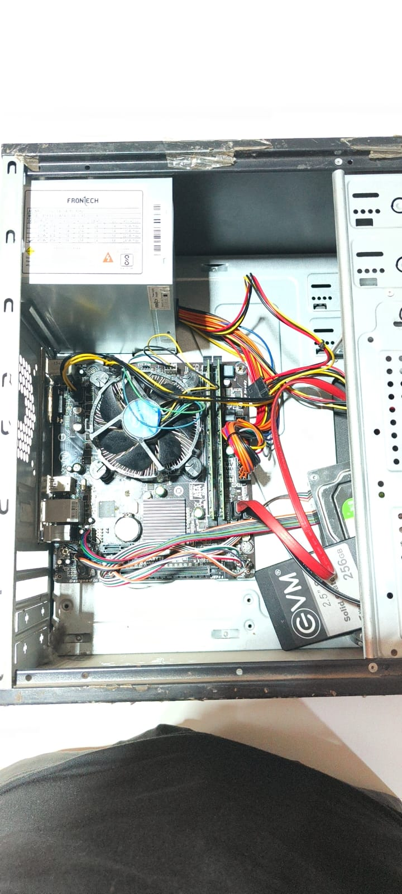

- Create a checklist of safety precautions and tools needed before starting the PC assembly/disassembly process, and explain why each is important
Ans :
PC Assembly/Disassembly Safety Checklist
✓ | Safety Precaution / Tool | Why It Is Important
☐ | Turn Off the PC | Prevents electrical shock and protects components from damage.
☐ | Unplug the Power Cable | Ensures no electricity is flowing into the system during work.
☐ | Disconnect All External Devices | Prevents accidental damage to peripherals and cables.
☐ | Use an Anti-Static Wrist Strap | Protects sensitive components from static electricity (ESD).
☐ | Work on a Clean, Flat Surface | Reduces the risk of losing screws or damaging components.
☐ | Avoid Carpeted Areas | Carpets can generate static electricity that may damage hardware.
☐ | Handle Components by the Edges | Prevents damage to circuits, pins, and connectors.
☐ | Keep Liquids Away | Prevents short circuits and component damage.
☐ | Organize Screws in a Container | Prevents losing small screws and parts during disassembly.
☐ | Read the Motherboard Manual | Helps identify connectors, slots, and installation procedures.

Tools Required
✓ | Tool | Purpose
☐ | Phillips Screwdriver | Used to remove and install cabinet and component screws.
☐ | Anti-Static Wrist Strap | Grounds the user to prevent static discharge.
☐ | Small Screw Container | Keeps screws organized and prevents loss.
☐ | Flashlight (Optional) | Helps view connectors and components inside the cabinet.
☐ | Cable Ties | Used for cable management and improved airflow.
☐ | Thermal Paste | Required when reinstalling the CPU cooler.
☐ | Soft Brush or Air Blower | Removes dust from components safely.
☐ | Cleaning Cloth | Used for cleaning the cabinet and components.

Pre-Assembly/Disassembly Checklist
☐ PC is shut down completely.
☐ Power cable is unplugged.
☐ Monitor, keyboard, mouse, and other peripherals are disconnected.
☐ Anti-static wrist strap is worn.
☐ Workspace is clean and dry.
☐ Required tools are available.
☐ Screw container is ready.
☐ Motherboard manual or system documentation is available.
☐ Components will be handled carefully by their edges.
☐ No food or liquids are near the workspace.
Conclusion
Following these safety precautions and using the correct tools helps prevent hardware damage, electrical hazards, lost components, and installation errors. Proper preparation ensures a safe and successful PC assembly or disassembly process.

